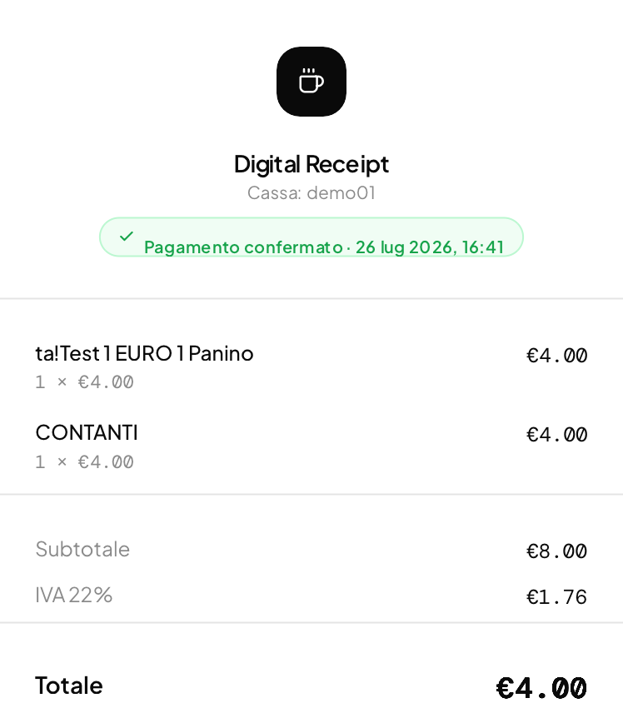
Log di Fiscal Processor:
[2026-07-26T14:40:32.590Z] [CONFIG] Configurazione caricata da: C:\Fiscal\config.json
[2026-07-26T14:40:32.594Z] [START] === RECEIPT PROCESSOR AVVIATO ===
[2026-07-26T14:40:32.602Z] [INIT] Ignorati 59 file già presenti all'avvio: ._receipt_2026-07-18T14-42-53.txt, receipt_20260719_223159_pj26f7u8v.txt, receipt_20260719_223204_s27d0edt7.txt, receipt_20260719_223215_3dv36fkow.txt, receipt_20260719_223218_euk6p8tfb.txt, receipt_20260719_223339_yeg3x2f7s.txt, receipt_20260719_223346_tnniuqrlw.txt, receipt_20260719_223917_m37sdbs39.txt, receipt_20260719_223934_yzrwlgyvf.txt, receipt_20260719_232320_agh3ke3dm.txt, receipt_20260719_232345_ngbueam23.txt, receipt_20260719_234306_wb8a41jgt.txt, receipt_20260719_234307_ervl53kcd.txt, receipt_20260719_234308_gyv2v0x5a.txt, receipt_20260719_234309_zfuj8e0uq.txt, receipt_20260719_234847_oy6wj884s.txt, receipt_20260719_234849_b3aqkf06s.txt, receipt_20260720_162901_i30s5ru6f.txt, receipt_20260720_162903_j9x2flala.txt, receipt_20260720_162904_885tsyrez.txt, receipt_20260720_164530_x2lx8exy0.txt, receipt_20260720_164606_jlqmgs5i2.txt, receipt_20260720_164610_0008hgaii.txt, receipt_20260720_164914_n4rbaxt5d.txt, receipt_20260721_165308_8w9w8ejqw.txt, receipt_20260721_165310_g95me5zrt.txt, receipt_20260721_165311_km4e4y1dw.txt, receipt_20260721_165312_1xgfy9rge.txt, receipt_20260721_174941_7pi4pl1s6.txt, receipt_20260721_175012_5dbzb7xm0.txt, receipt_20260721_175017_d3px4v11v.txt, receipt_20260721_175018_zqbfi21rb.txt, receipt_20260721_175036_9s1kczk66.txt, receipt_20260721_175135_rfk2csg03.txt, receipt_20260721_175142_jeupiq6ss.txt, receipt_20260721_175203_j5y9drqoj.txt, receipt_20260721_180139_6hv1fb14m.txt, receipt_20260721_180141_3swjtutpe.txt, receipt_20260721_180142_1sdy15yof.txt, receipt_20260721_180143_cldmj745m.txt, receipt_20260722_090706_b8vtteu93.txt, receipt_20260722_090717_fk4lh0qpk.txt, receipt_20260722_090732_z1ghsh509.txt, receipt_20260722_090750_qzdxcnvl3.txt, receipt_20260722_090928_jf6uwor88.txt, receipt_20260722_091510_tq441mtqq.txt, receipt_20260722_091521_n22aidf4m.txt, receipt_20260722_091524_yj28x0d0m.txt, receipt_20260722_091528_4egdn5785.txt, receipt_20260722_091752_qubude8it.txt, receipt_20260722_091801_quul03apd.txt, receipt_20260722_091804_u39pg9qu1.txt, receipt_20260722_092226_n6rvaqy1y.txt, receipt_20260722_171813_7g5wqqjj8.txt, receipt_20260722_171814_smd4qdg4a.txt, receipt_20260722_171815_0rvuvj1zy.txt, receipt_20260722_171828_7r5rkahha.txt, receipt_20260723_164025_rfide6h3l.txt, receipt_20260723_175730_7sx7668nc.txt
[2026-07-26T14:40:32.603Z] [WATCH] Inizio monitoraggio cartella di cattura
[2026-07-26T14:40:32.609Z] [TRAY] System Tray Icon creato (modalità console)

🧾 SCONTRINO DIGITALE - SYSTEM TRAY
=====================================
Comandi disponibili:
p - Stampa ultimo scontrino
s - Stato
q - Esci
=====================================

> [2026-07-26T14:40:32.618Z] [TCP] Server TCP avviato sulla porta 9100 - scrive in C:\FiscalPrintLocalPort\output.prn
[2026-07-26T14:41:08.724Z] [WATCH] Nuovo file rilevato: receipt_20260726_164106_v57jvt0az.txt
[2026-07-26T14:41:08.725Z] [SKIP] Ignorato file di comando/non scontrino (3 caratteri): receipt_20260726_164106_v57jvt0az.txt
[2026-07-26T14:41:08.726Z] [WATCH] Nuovo file rilevato: receipt_20260726_164107_mspxac9oh.txt
[2026-07-26T14:41:08.727Z] [PROCESS] Elaborazione file: receipt_20260726_164107_mspxac9oh.txt
[2026-07-26T14:41:08.730Z] [PROCESS] Ricevuta normalizzata: totale €4
[2026-07-26T14:41:08.731Z] [SEND] Invio ricevuta: totale €4
[2026-07-26T14:41:08.737Z] [FIREBASE] Firebase Admin SDK inizializzato
[2026-07-26T14:41:09.263Z] [SUCCESS] ✅ Ricevuta inviata a Firebase: demo01_2026-07-26T14:41:08-730Z_b72hwzj93
[2026-07-26T14:41:09.265Z] [QUEUE] Coda offline vuota
[2026-07-26T14:41:09.265Z] [PROCESS] Elaborazione completata con successo
[2026-07-26T14:41:09.267Z] [PROCESS] 📁 File spostato in processed/: receipt_20260726_164107_mspxac9oh.txt
[2026-07-26T14:41:09.268Z] [PRINT] 🖨️ Finestra di stampa aperta (60 secondi)
[2026-07-26T14:41:10.738Z] [WATCH] Nuovo file rilevato: receipt_20260726_164109_tlgyvcwbv.txt
[2026-07-26T14:41:10.740Z] [PROCESS] Elaborazione file: receipt_20260726_164109_tlgyvcwbv.txt
[2026-07-26T14:41:10.741Z] [PROCESS] Ricevuta normalizzata: totale €N/A
[2026-07-26T14:41:10.742Z] [SEND] Invio ricevuta: totale €N/A
[2026-07-26T14:41:10.743Z] [FALLBACK] ⚠️ Totale non parsato (N/A), invio comunque come fallback con raw_text
[2026-07-26T14:41:10.771Z] [SUCCESS] ✅ Ricevuta inviata a Firebase: demo01_2026-07-26T14:41:10-741Z_lbsm9gup8
[2026-07-26T14:41:10.771Z] [QUEUE] Coda offline vuota
[2026-07-26T14:41:10.773Z] [PROCESS] Elaborazione completata con successo
[2026-07-26T14:41:10.774Z] [PROCESS] 📁 File spostato in processed/: receipt_20260726_164109_tlgyvcwbv.txt
[2026-07-26T14:42:10.782Z] [PRINT] 🖨️ Finestra di stampa chiusa

